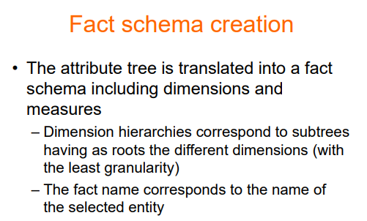

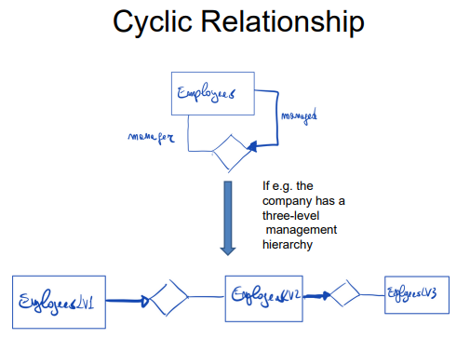

An employee is managed by someone else that is an employee. THe hierarchy must stop at some point, it is not a real loop. You represent only a part of the loop.
Emp1 managed by emp2 that is managed by emp3

⟹ is not really a cycle, is up to you decide where to stop

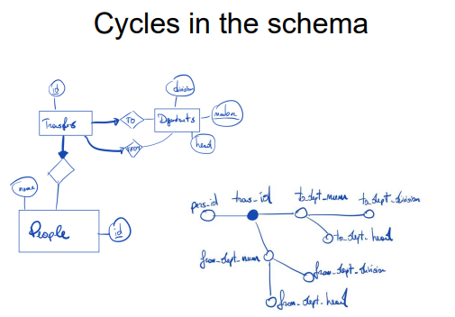
transfer either to the department or from the department. Even if it looks like a cycle it is not, they are distinct.

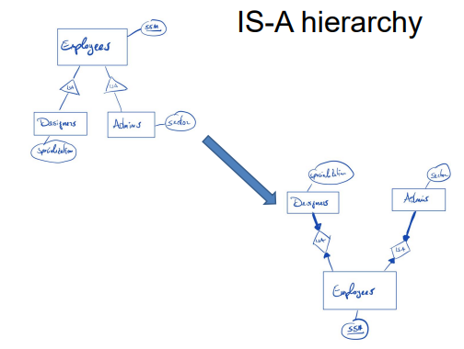

An employee can have at most a designer and an admin. Can have overlapping.

